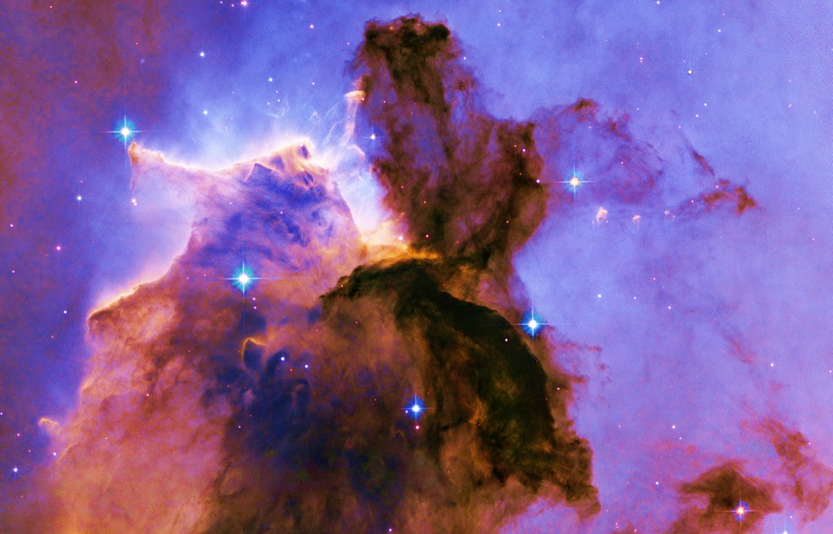

Intuitive Tarot Readings, Angel Gypsy Card Readings, Angel Card Readings, Astrology Reports, Astrology Insight Consultations, Mediumship

Available to read at your Parties, Fun Events, Corporate Functions,

Individual Readings in a Private Sitting, Fun Gatherings, Girl's Night Out, Bachelorette Parties, Readings at your private, fundraising, or charity events.

Readings can be done in a private sitting, individually, or with a group of friends. Can also be delivered in a gallery setting to share with a group.

*“Psychic/Mediumship and Intuitive Card readings filled with insight, and conveyed with compassion and empathy”*

Call Luminescence

603-315-9478